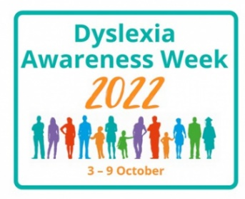
Dyslexia Week 2022 will be taking place from Monday 3rd October - Sunday 9th October this year.
Dyslexia Awareness Week is an annual event aimed at further understanding and raising awareness about dyslexia; what it means, what it is and what can be done to support people who have dyslexia.
What is Dyslexia?
Dyslexia is a very common difficulty that some people face when reading text or words. Because intelligence is not impacted, it is not described as a learning disability but as a Specific Learning Difficulty (SpLD). The main disruption that dyslexia causes is difficulty with phonological awareness, which is our ability to understand sounds and letters (phonemes).
Each person with dyslexia is different. For some people, it may just slow them down when reading and writing; for others, dyslexia can cause more serious visual interruptions when reading, where words and letters appear blurred. A person with dyslexia might:
- read and write very slowly;
- have poor or inconsistent spelling;
- confuse the order of letters in words;
- put letters the wrong way round (such as writing "b" instead of "d");
- find it hard to carry out a sequence of directions;
- struggle with planning and organisation;
- understand information when told verbally, but have difficulty with information that's written down.
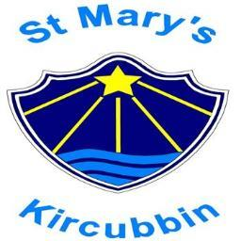
People with dyslexia often have good skills in other areas, such as creative thinking and problem-solving. Because dyslexia affects an estimated 10% of the UK population, it’s very important to fully understand what it is.

Dyslexia Week 2022 and St Mary’s
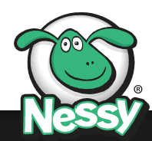
We have decided to focus on Dyslexia Awareness Week in school and would love to provide you with the opportunity to learn more about how dyslexia can affect people. If Dyslexia is something you would like to know more about and perhaps how to support your child, we recommend you complete the Dyslexia Awareness Training in partnership with Nessy.
Nessy is offering free dyslexia awareness training. Follow the link for the parent edition:
https://www.nessy.com/en-gb/product/understanding-dyslexia-parent-edition-free-for-dyslexia-awareness-month
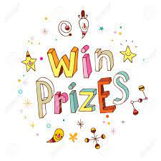
The training can be done on a smartphone, tablet or computer. The course takes about 2 hours but can be completed in bitesize chunks. A certificate is awarded when the course is completed.
If you complete the course please send the certificate to cdonnelly523@c2kni.net or print it out and send it in to school with your child. You will be put into a draw for a prize. Closing date: Thursday 27th October 3pm

