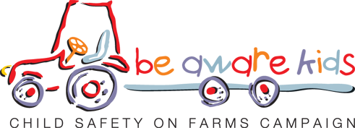

27 May 2020

Dear Principal

The Health and Safety Executive for Northern Ireland is committed to eliminating incidents on farms that in the past have resulted in children being killed or injured.
Through our “Be aware kids - Child safety on farms” campaign we have seen a significant reduction in such accidents, however we can never be complacent and must all work together to promote this important message.

Unfortunately this year due to the unprecedented circumstances we find ourselves in with Covid-19, our staff will not have the opportunity to visit rural primary schools in the run up to the summer holidays to deliver our farm safety messages. However we still wish to promote our farm safety poster competition which we have been running successfully now for a number of years as we feel this is also an excellent way of getting our important safety messages out to farming families. This year we need your help and support more than ever to run our competition.

We are inviting Primary School pupils (Foundation, Key Stage 1 & Key Stage 2) and pupils from Special Schools to take the opportunity to enter our poster competition which will commence on 1st June 2020 and run for 12 weeks. To do so each child should draw or paint a picture and the design of this picture should be based on the key dangers on the farm from one of the following four categories –

- Dangers from slurry
- Dangers from farm animals
- Dangers from tractors & other farm machinery
- Dangers from falls & falling objects

Each week we will invite entries from one of the above categories. The theme for each week will be announced every Monday on HSENI’s Facebook page and on our website www.hseni.gov.uk. Competition Terms & Conditions are attached and can also be viewed on our website.

Entries should be submitted portrait style on either A3 or A4 sized plain paper. To ensure entry to the competition is as simple as possible this year, we would ask that a photograph or scan of the completed picture is e-mailed to safestart@hseni.gov.uk.
A cover note on the e-mail should state the child’s name, primary school attended and contact telephone number for a parent/guardian or responsible adult.

We will select a winner each week for the 12 weeks of the competition and winners will be notified the following week. .
Prizes for each of the 12 winners will be a £30 One4all gift card.

It is important that after a picture is submitted by e-mail, the original hard copy is retained as we will require the 12 overall winners selected to provide this for printing purposes. Please note, failure to provide a hard copy will result in the prize not being awarded.

In previous years HSENI has produced a calendar made up of the winning entries to the competition and the calendar has been distributed to over 42,000 rural homes throughout Northern Ireland, HSENI hopes if possible to produce a calendar for 2021 from the winning entries to this year’s competition.

For more information on “child safety on farms” go our website www.hseni.gov.uk/articles/be-aware-kids-child-safety-farms-campaign or you can e-mail safestart@hseni.gov.uk

I trust that you will support this worthwhile campaign and help promote entries from the children who attend your school by sharing our notification out as widely as possible to your parents and pupils and encourage the children to take part. We look forward to receiving some wonderful art work highlighting the very important child safety on farms messages and appreciate your help with the promotion of the competition.

Thank you in advance & stay safe.

Yours faithfully

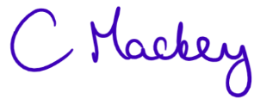

Camilla Mackey
Principal Inspector Agri-food team
HSENI

