Choosing the right Free e book
- Log on to AR Book Guide
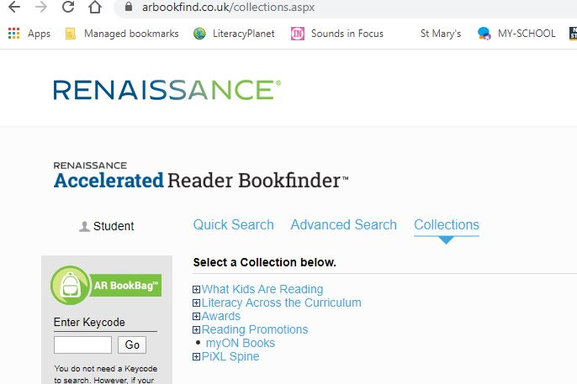

- Click on collections and myON Books

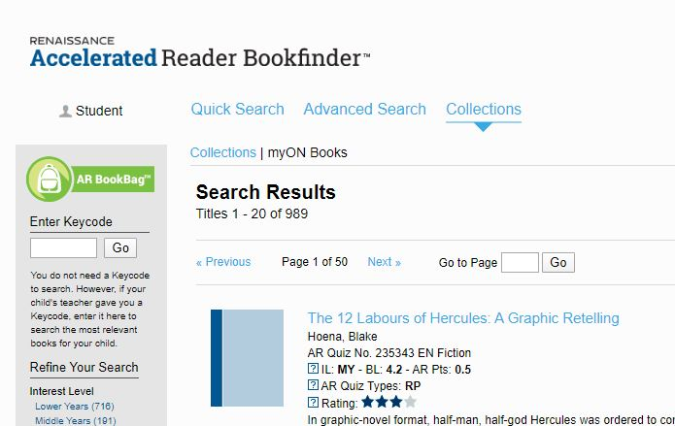

- Choose an interest level based on your child
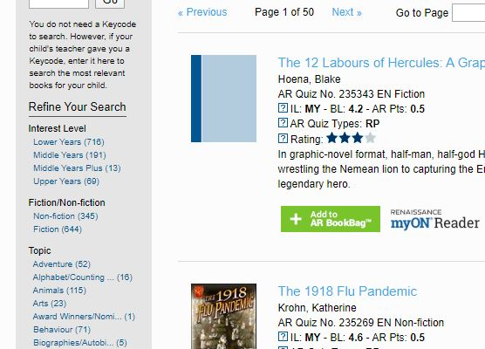

Then click on a ZPD range appropriate to your child(you can get this from your child or if they don’t remember it, from your child’s teacher or by messaging the school mobile
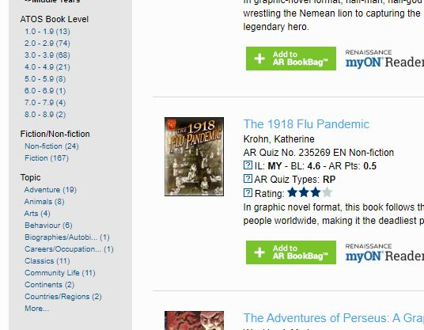

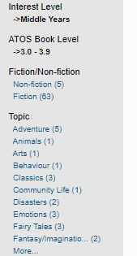
You can refine your search to choose a topic or genre that your child likes.

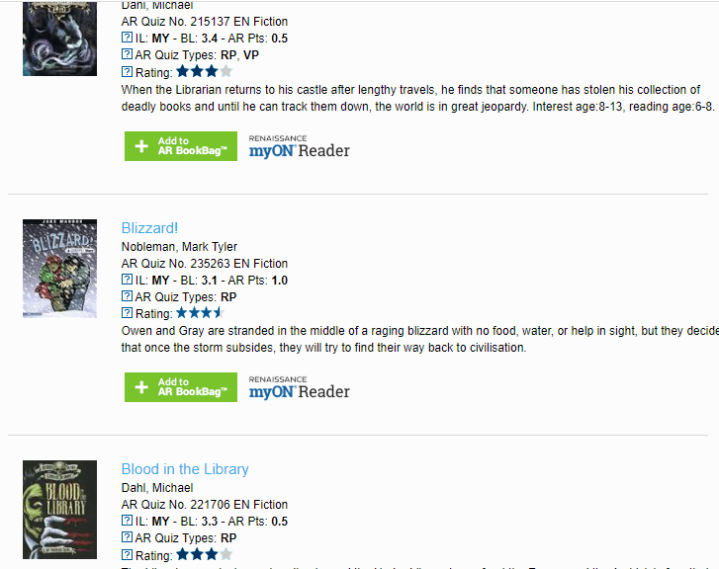

Browse the availabe books and make a note of the ones your child feels they would like to read
Make a note of the title and author of several books that your child would like to read.

